SHAMROCK STREET SIGN
ORDER FORM
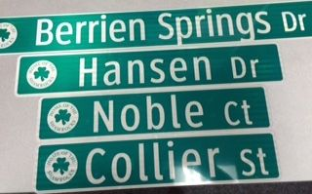
$40 – 24, 30, & 36 inches long$45 – 48 inches long
Suffix – Ave, Alley, Blvd, Cir, CT, Dr, Hwy, Hill, Jct, Lane, LN, Loop, Pkwy, Pl Pvt, Plz, Rd, Sq, St, Ter

Name Suffix 24 in 30 in 36 in 48 in
____________________________________________________________________________
____________________________________________________________________________
____________________________________________________________________________
____________________________________________________________________________
____________________________________________________________________________
____________________________________________________________________________
____________________________________________________________________________
____________________________________________________________________________
____________________________________________________________________________
____________________________________________________________________________
____________________________________________________________________________
____________________________________________________________________________
____________________________________________________________________________
____________________________________________________________________________
____________________________________________________________________________
____________________________________________________________________________
____________________________________________________________________________
____________________________________________________________________________
____________________________________________________________________________
____________________________________________________________________________

